CTM-I Use Case

User Edit

Version 0.1

Use Case Name | User Edit
Actor | Firm User, Market Ops, Ops, App Support
Pre-conditions /Assumptions | User has selected a user from the User Maintenance Use Case to edit.
Post Conditions | The user has the option of returning to the User Maintenance Use Case.
Screenshot | 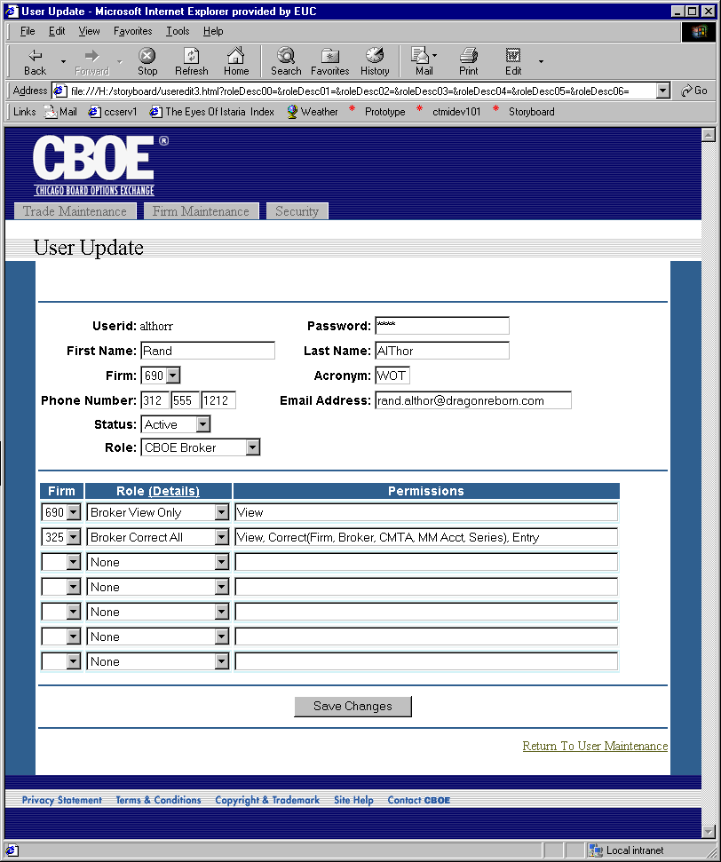
Flow of Events | - User has selected a specific user to edit from the User Maintenance Use Case.  - Infra Security Admin Service will be queried for the latest version of the User data.  - If the user has a role of CBOE Broker, then CTM-R will be queried for the latest version of the firm broker roles through Operator Passwords.  - User Maintenance screen appears with the data previously retrieved.  - The screen contains two sections, the User Data section and the Firm Broker Role section.  - The User Data section contains the following fields  - Userid – Not editable  - Password – Can be reset, but is not displayed in a readable format  - First Name  - Last Name  - Firm – Contains the list of firms the user doing the edit is authorized for.  - Acronym – Must be unique across all users, if not null  - Phone Number  - Email Address  - Status – List of possible status (Active and Disabled are supported by Infra)  - Role – List of possible roles. The list of roles is limited by the authorization of the user performing the edit. A user cannot grant a role with higher permissions than their role.  - The User Data section is editable if the user doing the edit is authorized for the primary firm the user being edited has been assigned. For example, if the user being edited has a primary firm of 000, the user editing the record would be allowed to edit the User Data section only if they are authorized for firm 000.  - The Firm Broker Role section of the screen is only visible if the user being edited is of the role “CBOE Broker”.  - The Firm Broker Role section contains a set of rows for input. The number of rows will equal the total number of firms the user can give authorization for. If the user can authorize more than 10 firms, then the display will show at least 2 blank rows.  - Each row will have the following fields  - Firm – Cannot be duplicated on two rows  - Role – The role the user is granted for the firm. The header for this column will contain a link to view the details for the Firm Broker Roles.  - Permissions – A view only display of a summary of the permissions the selected role authorizes.  - Pressing the “Save Changes” button will request the changes to be saved. The changes will be sent to the Infra Security Admin Service. Any changes to the Firm Broker Roles will be saved through operator Passwords in CTM-R.  - The results of the save will display on the screen.
Alternative Path | - If the screen is in add mode, the userid field is editable.

